Euan-Angus MacLeod

emacleod@alaska.edu

Projecting Environmental parameters for Driving Coastal Erosion Models

Geospatial Programming (CSCE A690) Term Project

## Topic Overview

Climate change is one of the greatest threats faced by Arctic coastal communities including those in Arctic Alaska. The Arctic coastal zone has seen a rapid rise in air and water temperature, a lengthening of the open water period, and an increase in the spatial extent of open water due to sea ice reductions. The changing environmental conditions have led to larger ocean waves and to accelerating thaw of coastal permafrost which together contribute to increased coastal erosion rates and coastal flooding. To understand and adapt to this reality, erosion and flood modelling is utilized to convey the risk and vulnerability that these communities face. Process-based and semi-empirical coastal erosion models have been developed for Arctic Alaska. They have been calibrated and validated with historic environmental data. The objective of this project is to develop methodologies to forecast environmental data in formats that will be used in forecasting for coastal erosion and coastal flooding models.

Forecasted environmental data for coastal erosion forecasts will be developed based on output from coupled atmosphere-ocean Global Circulation Models (GCM). The environmental parameters to be forecasted are sea surface temperature, sea ice extent, wind vectors and atmospheric pressure. First, output from five GCMs, taken from the Coupled Model Inter-comparison Project 5 (CMIP5) experiment, will be selected based their relevance to Arctic Alaska.

The methodology for down-scaling the four environmental parameters from the GCM output into a format useful for driving a coastal erosion model is as follows:

* High resolution historic data will be mined to develop relationships between the high-resolution data in the historic period and the low-resolution data from the GCM's output.
* Once this relationship is obtained, we will use it to develop high resolution data for driving the coastal erosion forecast model based on the low-resolution GCM output.

The primary focus will be to develop the short term (5-30 year) forecast that will be the most useful for the end users of the erosion/flood modelling in the planning process. The long term (50-100 year) environmental parameters in order generate projections further into the future will also be investigated.

The project will be broken in to phases to allow a section to be jettisoned if there is not enough time to complete the project in one semester.

## Literature Review

Data is the keystone to success in modeling. Modeling to try to maximize efforts and capital to sustain a habitable environment, whether it is through estimation of coastal erosion to the estimation of land vulnerable to vast forest fires. Modeling has an impact on communities, their property, local policy which in turn effects government spending. The Arctic, in general, is in an unfortunate situation where due to ever increasing changes in climate, it needs modeling more than ever but has a lack of environmental data both spatially and temporally.

As coastal erosion poses a threat to coastal communities and oil and military infrastructure, erosion modelling provides the best way of assessing the risk associated with a rapidly changing coast. One such model that is purpose built for the type of erosion that occurs on the north coast of Alaska (niche erosion – block collapse) has been created by Tom Ravens of UAA (Ravens, et al., 2012).

The niche-block erosion process models developed by Ravens can be described as an integrated system of models that allow an approximation of coastline change with time based on environmental parameters of wind speed, wind direction, water temperature. Meteorological data from Barrow was utilized for the modeling of wave height by using a nearshore wave model (SWAN) and water level relative to the mean sea level using a basic surge model reflecting the extent of open water for the given time. Through the wave height, sea level the nearshore water temperature and other parameters, the niche erosion of a block and then the thermal and mechanical erosion of the separated block could be modelled as illustrated in Figure 1.

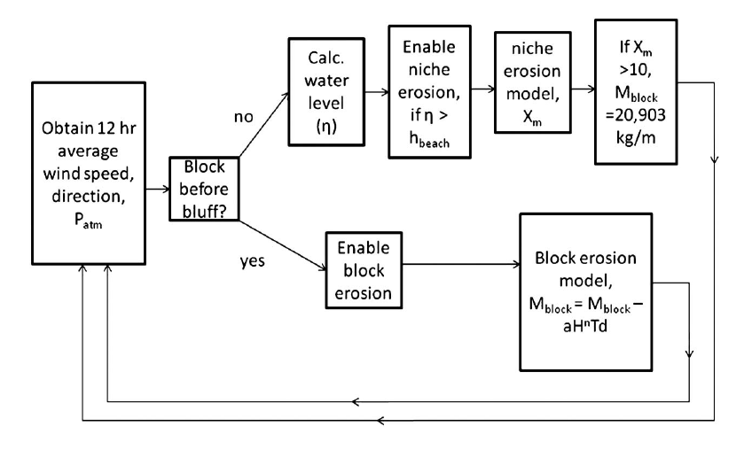

Figure 1 - Flow chart used in shoreline change model (Ravens, et al., 2012)

The level of beach elevation is a sensitive parameter that was also included. This was calculated using the available wind, ice and water temperature. Niche growth was enabled in the model if the mean water height was above the beach elevation meaning the relatively warmer water can thermally erode the permafrost bluff.

The model and its sub routines were driven by four parameters: nearshore water temperature, atmospheric pressure, wind vector and open water extent.

To try and estimate the rate of coastal erosion into the future, we need to project the environmental parameters that are used to drive the process-based model; we do this by using Global Circulation Models (GCMs). GCMs model different climate scenarios to produce a historic dataset and projected dataset for each environmental parameter it models.

The Global Circulation Models (GCMs) used in the downscaling were based on the based on the paper by JE Walsh et at, Global Climate Model performance over Alaska and Greenland (Walsh, et al., 2008). The paper compared and ranked a 15 GCM models for three parameters precipitation, atmospheric pressure and air temperature in which a list of five preferred models was produced. The models in the comparison were those from the Coupled Model Intercomparison Project 3 (CMIP3) – a project that collected output from coupled ocean-atmosphere models from a wide range of different research centers; the output was organized for the preparation of the Fourth Assessment Report (AR4) by the Inter-governmental Panel on Climate Change (IPCC) (Programme, 2009).

The Scenarios Network for Alaska and Arctic Planning (SNAP) group, a part of the International Arctic Research Center at the University of Alaska Fairbanks (UAF), has continued the analysis of the GCM models for their own analysis based on the same methods used in the JE Walsh et al paper. The following model output is from the Coupled Model Intercomparison Project 5 (CMIP5):

|  |  |
| --- | --- |
| Centre | Model |
| National Center for Atmospheric Research | NCAR-CCSM4 - Community Earth System Model 4 |
| NOAA Geophysical Fluid Dynamics Laboratory | GFDL-CM3 - Coupled Model 3.0 |
| NASA Goddard Institute for Space Studies | GISS-E2-R - ModelE/Russell |
| Institut Pierre-Simon Laplace | IPSL-CM5A-LR - IPSL Coupled Model v5A |
| Meteorological Research Institute | MRI-CGCM3 - Coupled General Circulation Model v3.0 |

The resolution of the GCMs can be from 200km to 600km; for impact assessment purposes, the resolution of the environmental data output from the GCM is too course. To utilize the GCM projection the output from the models need to be ‘downscaled’. To do this, a simple statistical downscaling method will be used called the ‘delta method’ (Ramirez-Villegas & Jarvis, 2010).

The delta method uses a training dataset to establish a relationship between observed data at the site and the historic dataset from the GCM for the same period of time. Delta method finds the differences between the two datasets and assumes that the difference between the model holds into the future – this is essentially calibrating the model. So, for each month within the training dataset the difference is noted (usually by factor), each individual month (Jan, Feb, Mar…) is then averaged to give 12 averaged difference or ‘anomalies’. Each average anomaly is then applied to its corresponding month in the projected dataset.

## Study Area

Drew Point, Alaska

Latitude: 70° 52' 37" (70.8769°) north

Longitude: 153° 56' 13" (153.9369°) west

## Deliverables

Using the delta method of downscaling, the following environmental parameters are to be downscaled:

* Near-shore water temperature
* Atmospheric Pressure at Sea Level
* Wind Vector
* Open Water Extent (downscaled only for the months of Jul-Oct)

As part of the downscaling intermediate outputs during the process need to be stored for checking purposes.

## Project Phases

To make the project is manageable, it has been broken into phases. Each phase contains an automation of one of the environmental parameters. One or more of the phases can be jettisoned if there is not enough time to complete all 4 phases.

1. Open Water Extent
2. Near-shore water temperature
3. Wind Vector
4. Atmospheric Pressure

## Methodology

This section outlines the manual method of extracting this data – where possible this should be automated to produce the desired output.

For the downscaling of the near-shore water temperature, atmospheric pressure and wind vector

* Specify location
  + Create a point – shape file
* Create Training Dataset
  + Load & extract observed dataset
    - Locate data source if different from original location – create shape file
    - data set location and length will vary with environmental parameter
  + Load & extract historic GCM data
    - Import the GCM data (create feature layer/multidimensional tools)
    - Subset the data (only data approx. above 69deg latitude)
    - Locate closest point to the location of the observed data
    - Import the timeseries for the point nearest to the data location
      * NetCDF table view/multidimensional tool
  + Create anomaly for the Training data set
    - For each record in the same time-period as the observed data set divide the GCM value by the observed value – this is your anomaly
    - These anomalies need to be averaged for each unique month of the year i.e all the January anomalies need to be averaged, February… etc
    - These anomalies should be stored for future reference
* Projecting the parameters
  + Load and Extract the GCM data
    - For the same point in the GCM model as before, import the timeseries for the point nearest to the data location
      * NetCDF table view/multidimensional tool
  + Projection of the data
    - Apply the average anomaly to each of the respective months in the projected dataset
    - Store this data

The projection of the environmental parameters is repeated for each of the GCM model outputs. Once the projected data is averaged, a graphical representation of the combined data is required.

* Note that the wind vector is split into its component parts – The wind scalars need to be combined to then be downscaled for both the training and the projected GCM datasets

For the open water extent this is more involved; rather than a single time series being downscaled, it’s a 2D surface.

* Specify location
  + Create a point – shape file
* Create Training Dataset
  + Load & extract observed dataset
    - The observed data are 25km resolution sea ice extent shapefiles (‘79-‘05)
    - The Open water extent here is idealized as a box:
      * From the location point, draw a perpendicular line from the coast (essentially North) to the sea ice extent
      * Store the distance to sea ice extent
      * From the midpoint of the line, for both the LHS and RHS of the live, draw a perpendicular line to the lateral sea ice extent
      * Store the distance of both the LHS and the RHS distances
      * Create an ‘aspect ratio’ for the LHS and RHS of the original line
        + Divide the LHS and RHS distances, respectfully, by the distance from the coast to the sea ice extent
        + Store both of these values
      * This needs to be repeated for each year (’79-’05) and for each model
  + Load & extract historic GCM data
    - Import the GCM data (create feature layer/multidimensional tools)
    - Subset the data (only data approx. above 69deg latitude)
    - Subset the data so sea ice concentration (‘sic’) is greater >= 15 (%)
    - Locate closest point that is perpendicular/directly north of the location of the observed data
    - Find the distance to the point from the coast lines – also not the sic value
      * Store this data
    - This needs to be repeated for each year (’79-’05) and for each model
  + Create anomaly for the Training data set
    - For each coast to sea ice distance, for the same time-period as the observed data, set divide the GCM value by the observed value – this is your anomaly
    - These anomalies need to be averaged for each unique month of the year i.e all the January anomalies need to be averaged, February… etc
    - Furthermore, the ‘aspect ratio’ is average as above; for each unique month of the year
    - These anomalies should be stored for future reference
* Projecting the parameters
  + Load and Extract the GCM data
    - Import the GCM data (create feature layer/multidimensional tools)
    - Subset the data (only data approx. above 69deg latitude)
    - Subset the data so sea ice concentration (‘sic’) is greater >= 15 (%)
    - Locate closest point that is perpendicular/directly north of the location of the observed data
    - Find the distance to the point from the coast lines – also not the sic value
      * Store this data
    - This needs to be repeated for each year (’06 - ’00) and for each model
  + Projection of the data
    - Apply the average anomaly to each of the coast to sea ice distance in the projected dataset
    - Store the data
    - Apply the aspect ratio for both the LHS and the RHS to each of the projected distances - this will yield an estimated lateral distance to sea ice from the center of the box
    - Store the data

## Datasets

The data has already been compiled and will be made available through a Google Drive folder.

Historic Data

* NSIDC Sea Ice Extent polylines (.shp)
* Barrow Observatory – Atmospheric Pressure/Wind Vector (.xslx)
* UW Dataset: Nearshore Water Temperature– Model Data (.xslx)

GCM Data (NetCDF)

|  |  |
| --- | --- |
| Centre | Model |
| National Center for Atmospheric  Research | CCSM4 - Community Earth System  Model 4 |
| NOAA Geophysical Fluid Dynamics Laboratory | GFDL-CM3 - Coupled Model 3.0 |
| NASA Goddard Institute for  Space Studies | GISS-E2-R - ModelE/Russell |
| Institut Pierre-Simon Laplace | IPSL-CM5A-LR -  IPSL Coupled Model v5A |
| Meteorological Research Institute | MRI-CGCM3 - Coupled General Circulation  Model v3.0 |
| Centre National de Recherches Météorologiques | CNRM - CM5 |

# References

Programme, C. M. I. P. -. W. C. R., 2009. *CMIP3 - Overview.* [Online]   
Available at: https://cmip.llnl.gov/cmip3_overview.html?submenuheader=1  
[Accessed 14 02 2018].

Ramirez-Villegas, J. & Jarvis, A., 2010. *Downscaling Global Circulation Model Outputs: The Delta Method // Decision and Policy Analysis Working Paper No. 1,* Cali, Colombia: International Center for Tropical Agriculture.

Ravens, T. M. et al., 2012. Process-Based Coastal Erosion Modelling for Drew Point, North Slope, Alaska. *Journal of Waterway, Port, Coastal and Ocean Engineering,* Issue Mrach/April, pp. 122-130.

Walsh, J. E. et al., 2008. Global Climate Model Performance over Alaska and Greenland. *Journal of Climate,* Volume 21, pp. 6156 - 6174.